Configure Azure Virtual Machine

- Log into the Azure Portal.
portal.azure.com

- Search to Virtual Machines & select Virtual Machines.
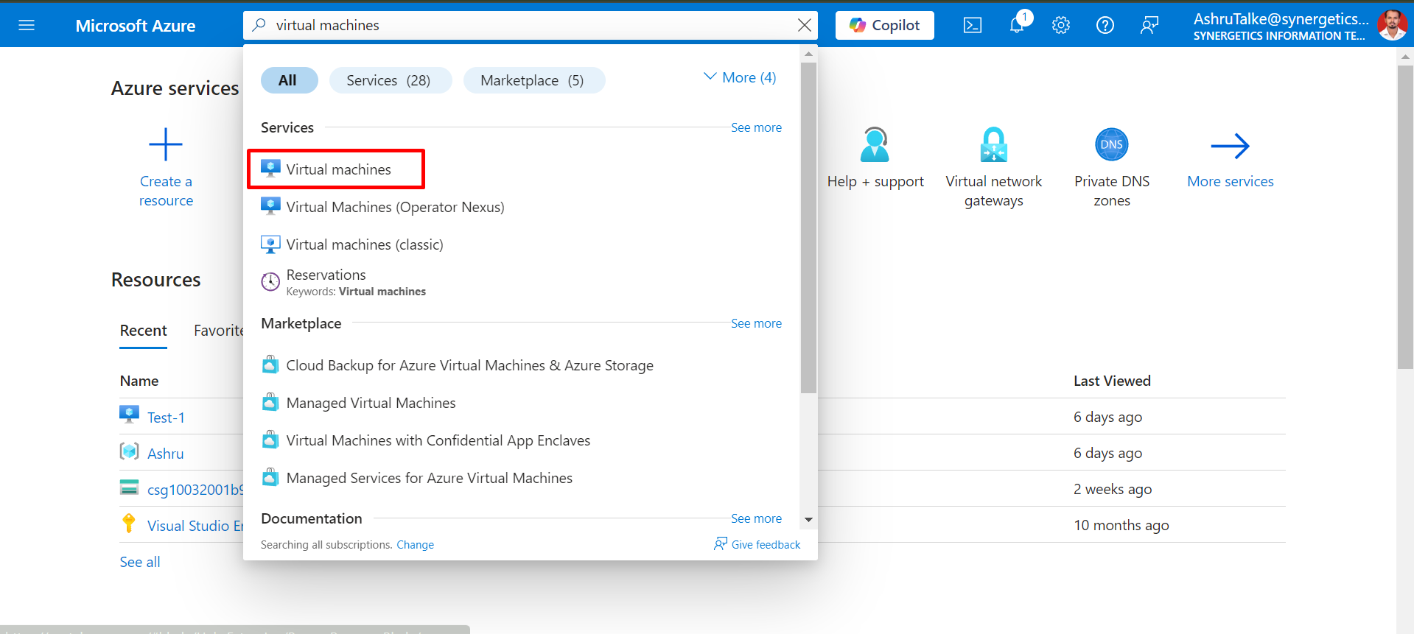

- Click on Create and then select + Azure virtual machine to start creating a new VM.
Configure the Basics Details.
  - Subscription: Choose your subscription.
  - Resource Group: Either select an existing resource group or create a new one.
  - Virtual Machine Name: Enter a name for your VM.
  - Region: Select the Azure region where you want to deploy the VM.
  - Availability options: select No infrastructure redundancy required.
  - (Azure offers a range of options for managing availability and resiliency for your applications. Architect your solution to use replicated VMs in Availability Zones or Availability Sets to protect your apps and data from datacenter outages and maintenance events)
  - Image: Choose an OS image, such as Windows Server 2019 or Ubuntu.
  - Size: Choose the VM size based on your needs (CPU and memory requirements).
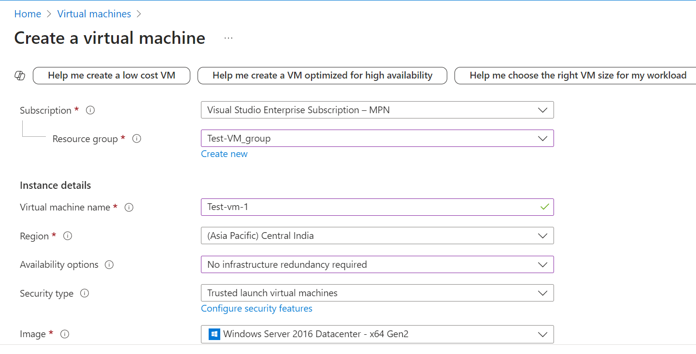
Fill The Administrator Account Details:
- Username: Enter a username.
- Password (for Windows) or SSH public key (for Linux): Set up access for your VM.
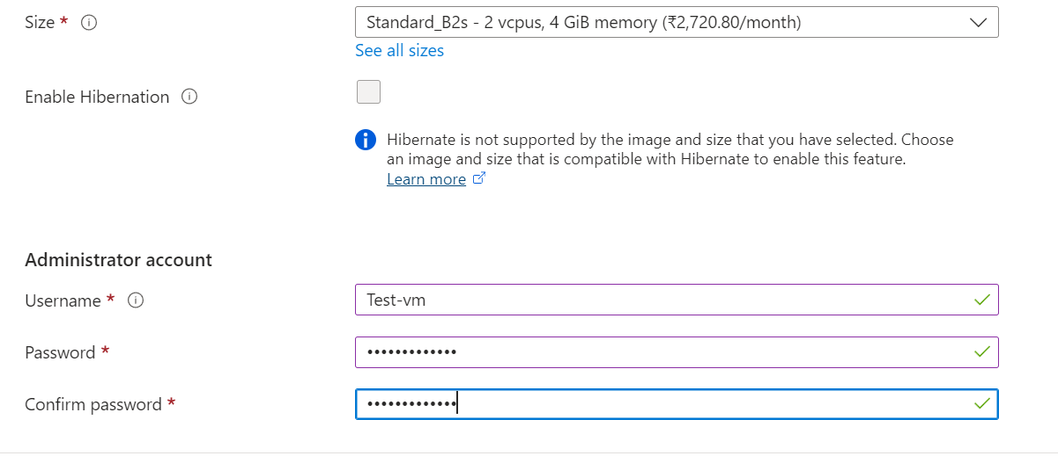
Select Inbound port rules
(Select which virtual machine network ports are accessible from the public internet.)
- Public inbound ports - Allow selected ports
- Select inbound ports - RDP (3389)
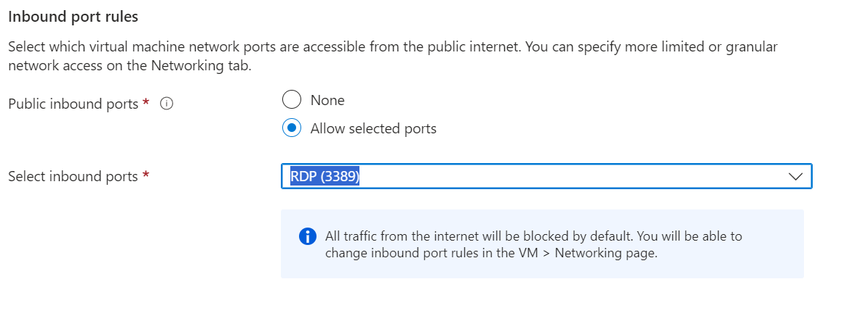

- Click On Next Disks
(Azure disk storage encryption automatically encrypts your data stored on Azure managed disks (OS and data disks) at rest by default when persisting it to the cloud.)
• Under OS Disk Type, choose the disk type (Standard SSD, Premium SSD, or HDD).

• Add Data Disks if needed for additional storage.

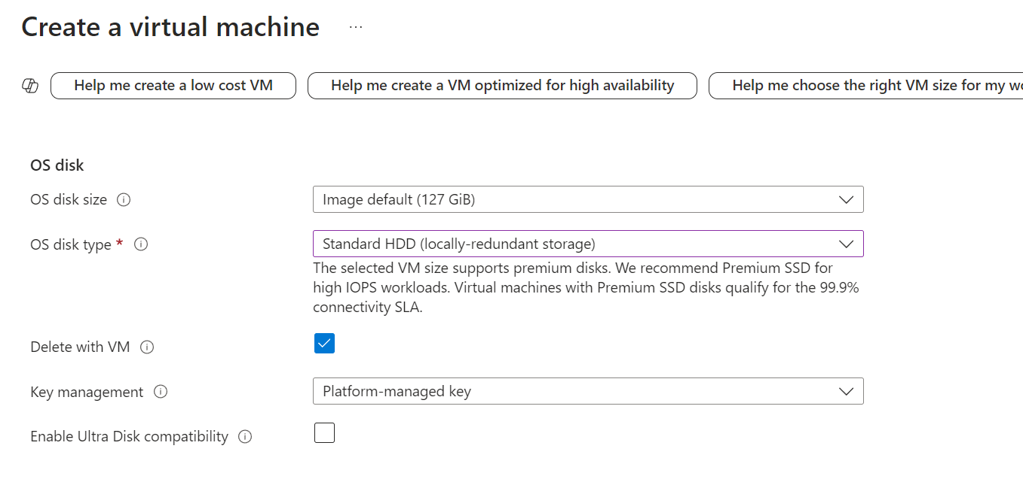
- Click On Next Networking.
(Define network connectivity for your virtual machine by configuring network interface card (NIC) settings. You can control ports, inbound and outbound connectivity with security group rules, or place behind an existing load balancing solution.)`

Configure Networking Details
  - Virtual Network: Create a new virtual network or select an existing one.
  - Subnet: Choose a subnet within the virtual network.
  - Public IP: Assign a public IP if you need external access to the VM.
  - Network Security Group (NSG): Configure inbound port rules, such as RDP (3389) for Windows or SSH (22) for Linux.
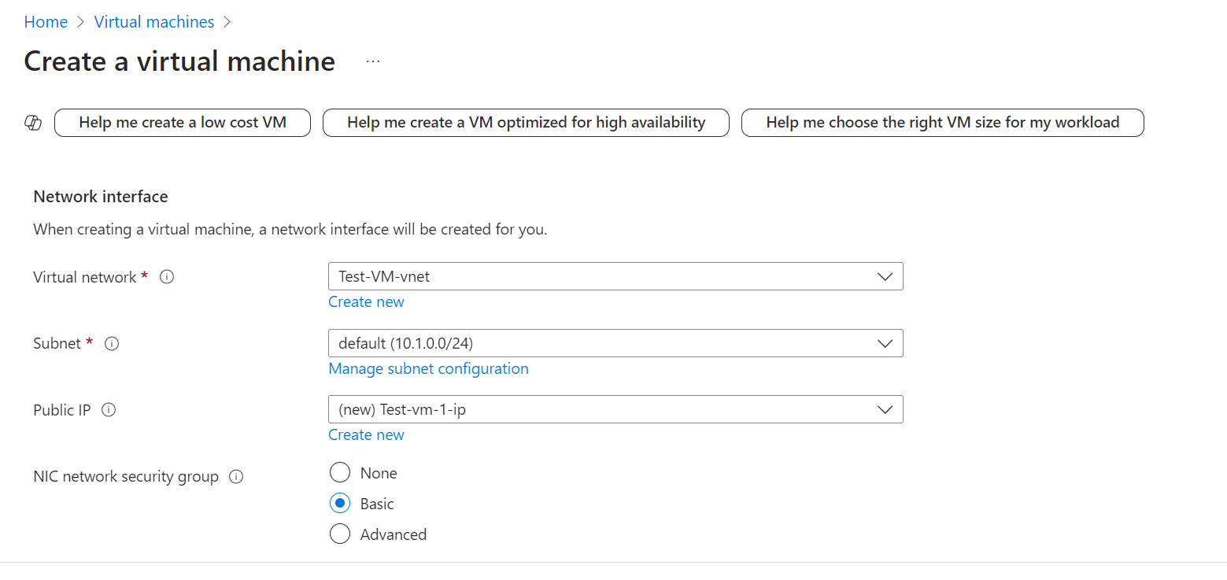

- Click On Next Management.

Configure Management details
- Auto-shutdown: Set an automatic shutdown schedule if desired.
- Monitoring: Enable monitoring and diagnostics as needed.

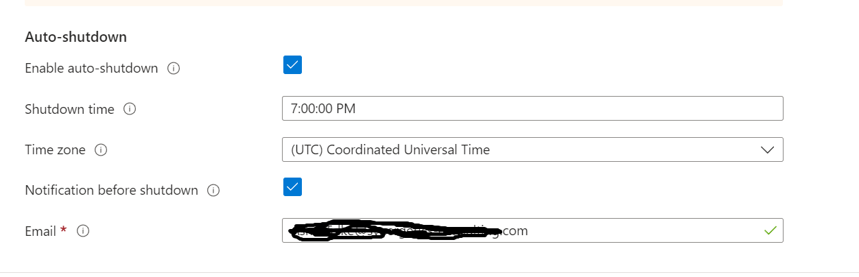
- Click On Next Monitoring

- Boot diagnostics: Enable or disable to capture logs during the VM boot process.
- Monitoring: Enable monitoring and diagnostics as needed.
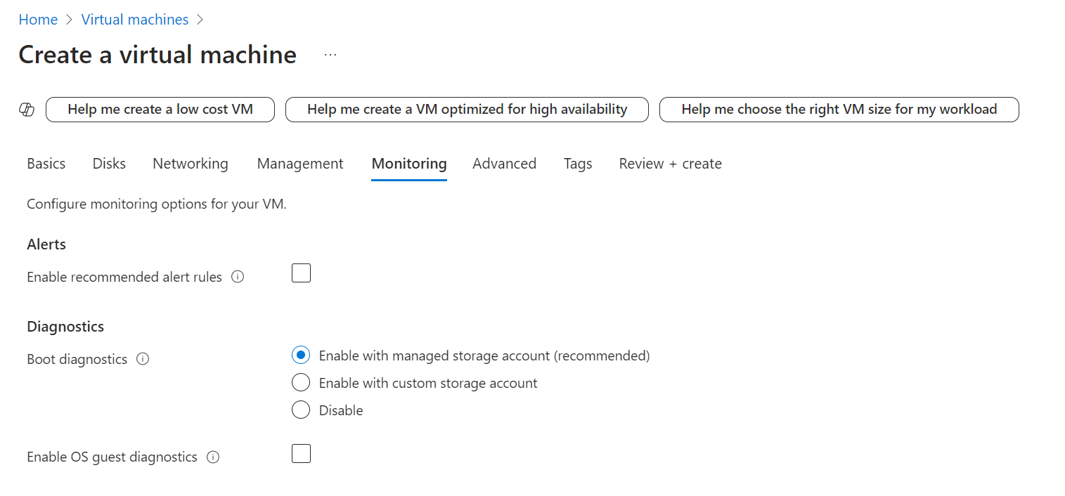
- Click On Next Advanced.
In the Advanced tab, configure additional VM extensions or cloud-init (for Linux VMs). This step is optional.

- Click On Next Tags.
(Tags are name/value pairs that enable you to categorize resources and view consolidated billing by applying the same tag to multiple resources and resource groups.)
- Click On Review + create.
• Review the VM settings and ensure all configurations are correct.
- Click Create to deploy your virtual machine.
- Connect to Your Virtual Machine
• For Windows VMs: Download the RDP file, open it, and enter your credentials.
• For Linux VMs: Connect using an SSH client and the public IP address.

Deletion of VM : After use please ensure you delete you resource for vm
Click on vm which you have created > Click on delete
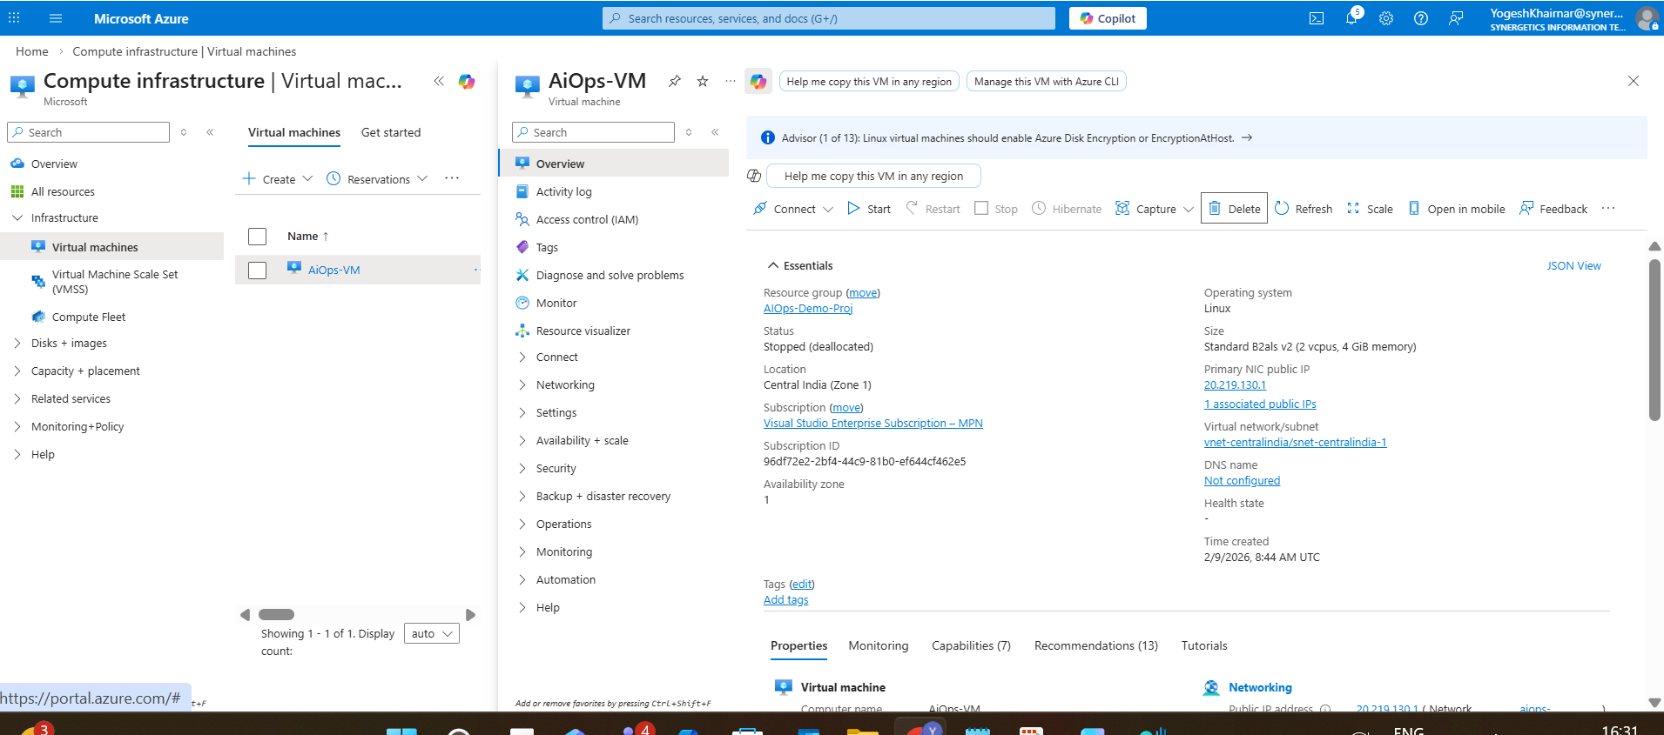
Check box the resource attached to vm > Click on delete.
